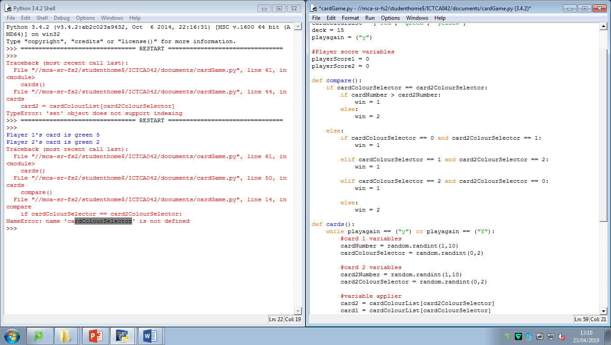

23/04/19 13:10

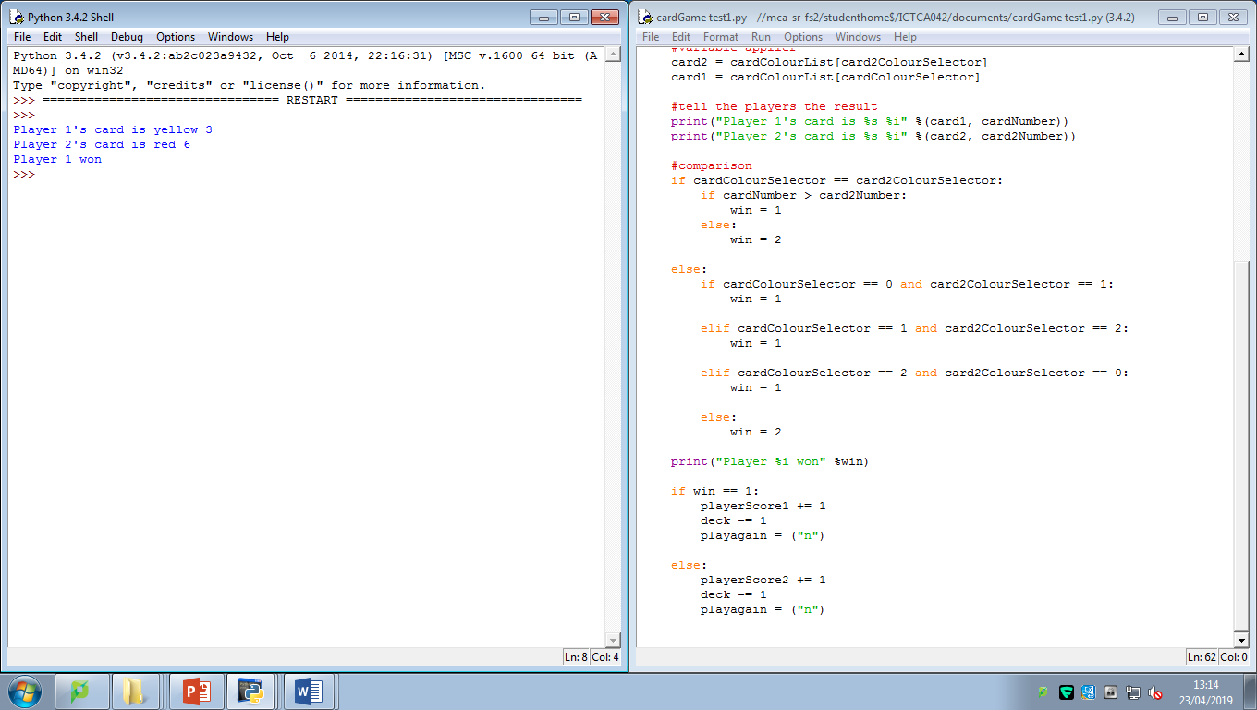

The error had something to do with the way I used definitions and this is the only fix